The List of Drupal Modules
07 Desember 2016
16:53

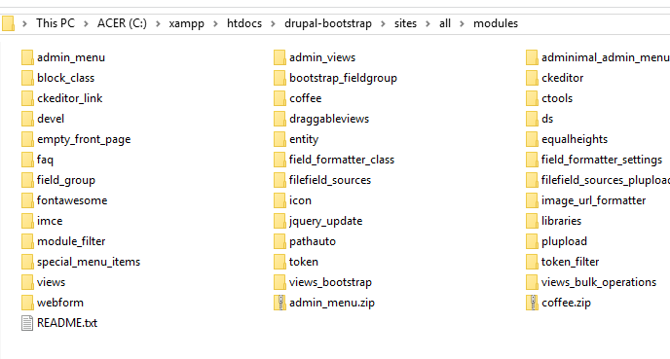

Material for Final Exam:
All modules above, those module are what for? how to used?
Hint: follow drupal video tutorilas "Drupal-bootstrap"

Assigment should be uploaded on github.com/[NIM]

